

A PROJECT REPORT

ON

JARVIS – VOICE ASSISTANCE

IN

MASTER OF SCIENCE(COMPUTER APPLICATION)

SEMESTER 1ST

SUBMITTED BY

Shende Sagar Ashok

PRN-1132220162

Kumbhar Tanaji Parth

PRN-1132220645

Kalgaonkar Shrikant Shridhar

PRN-1132220982

### Index

|  |  |  |
| --- | --- | --- |
| **Sr. No** | **Table of Content** | **Page No** |
| **1** | **Introduction** | **1** |
| 1.1 Existing System |
| 1.2 Need of the System |
| 1.3 Overview of the Project |
| **2** | **Analysis** | **2** |
| 2.1 Feasibility Study |
| 2.1.1 Technical feasibility |
| 2.1.2 Economical Feasibility |
| 2.1.3 Operational feasibility |
| 2.2 Hardware and Software requirement |
| **3** | **Design** | **3** |
| 3.1 Use Case Diagram | **3-4** |
| 3.2 Data Flow Diagram |
| 3.3 Component Diagram |
| **4** | **User Interface** | **5** |
| **5** | **Testing** | **6** |
| 5.1 Importance of testing |
| **6** | **Reports** | **7** |
| **7** | **Drawbacks and limitations** | **8** |
| **8** | **Future enhancement and conclusion** | **8** |
| **9** | **Bibliography** | **9** |

## 1. Introduction

### 1.1 Existing System –

Technology has rendered humanity with numerous blessings. From smartphones to medical equipment, the world has benefitted by several unimaginable tools. Viewing, listening & speaking are the basic elements of expression awarded by the nature to humans. Thus, today these elements have turned into features on digital devices.

### 1.2 Need of the System –

It is vital to integrate the facility of human voice recognition into digital devices. The accessibility improvements alone are worth considering. Speech recognition allows the elderly and the physically and visually impaired to interact with state-of-the-art products and services quickly and naturally.

### 1.3 Overview of the Project–

* Far from a being a fad, the overwhelming success of speech-enabled products like **Amazon Alexa** has proven that some degree of speech support will be an essential aspect of household tech for the foreseeable future. If you think about it, the reasons why are pretty obvious. Incorporating speech recognition into your Python application offers a level of interactivity and accessibility that few technologies can match.

* The voice assistance takes the voice input through our microphone (Bluetooth and wired microphone) and it converts our voice into computer understandable language gives the required solutions and answers which are asked by the user. This assistance connects with the World Wide Web to provide results that the user has questioned. Natural Language Processing algorithm helps computer machines to engage in communication using natural human language in many forms.

* Supported Tasks
  1. Date & Time
  2. Who’s who:
  3. Playing music
  4. Search using Google
  5. Search for Location information
  6. Google Translate

## 2. Analysis

### 2.1 Feasibility Study

2.1.1 Technical Feasibility –

It includes finding out technologies for the project, both hardware and software. For virtual assistant, user must have microphone to convey their message and a speaker to listen when system speaks. These are very cheap now-a-days and everyone generally possess them. Besides, system needs internet connection. While using JARVIS make sure you have a steady internet connection. It is also not an issue in this era where almost every home or office has Wi-Fi.

2.1.2 Economical Feasibility –

Here, we find the total cost and benefit of the proposed system over current system. For this project, the main cost is documentation cost. User also would have to pay for microphone and speakers. Again, they are cheap and available. As far as maintenance is concerned, JARIS won’t cost too much.

2.1.3 Operational Feasibility –

It is the ease and simplicity of operation of proposed system. System does not require any special skill set for users to operate it. In fact, it is designed to be used by almost everyone.

### 2.2 Hardware and software requirements

1. External Interface
   1. User Interface
      * Desktop interface

* 1. Hardware Interface
     + 4GB RAM and up
     + Processor: dual core and up

* 1. Software Interface
     + Windows 7 and above
     + Python 2.7 or later
     + Chrome Driver

* 1. Communication Interface
     + Microphone
     + Speaker

## 3. Design

### 3.1 Use Case Diagram

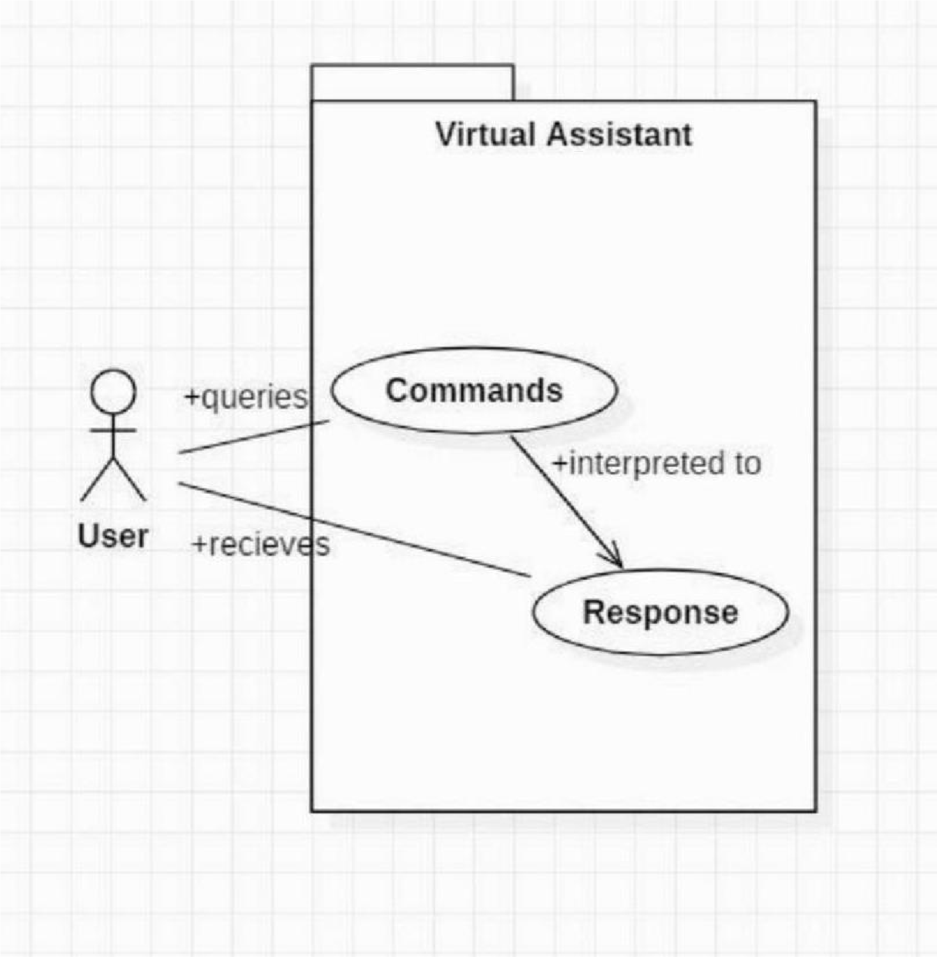

### 3.2 Data Flow Diagram

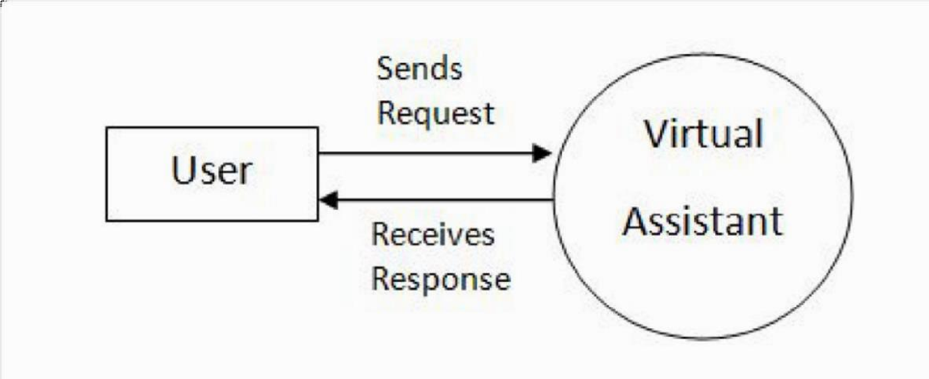

### 3.3 Component Diagram

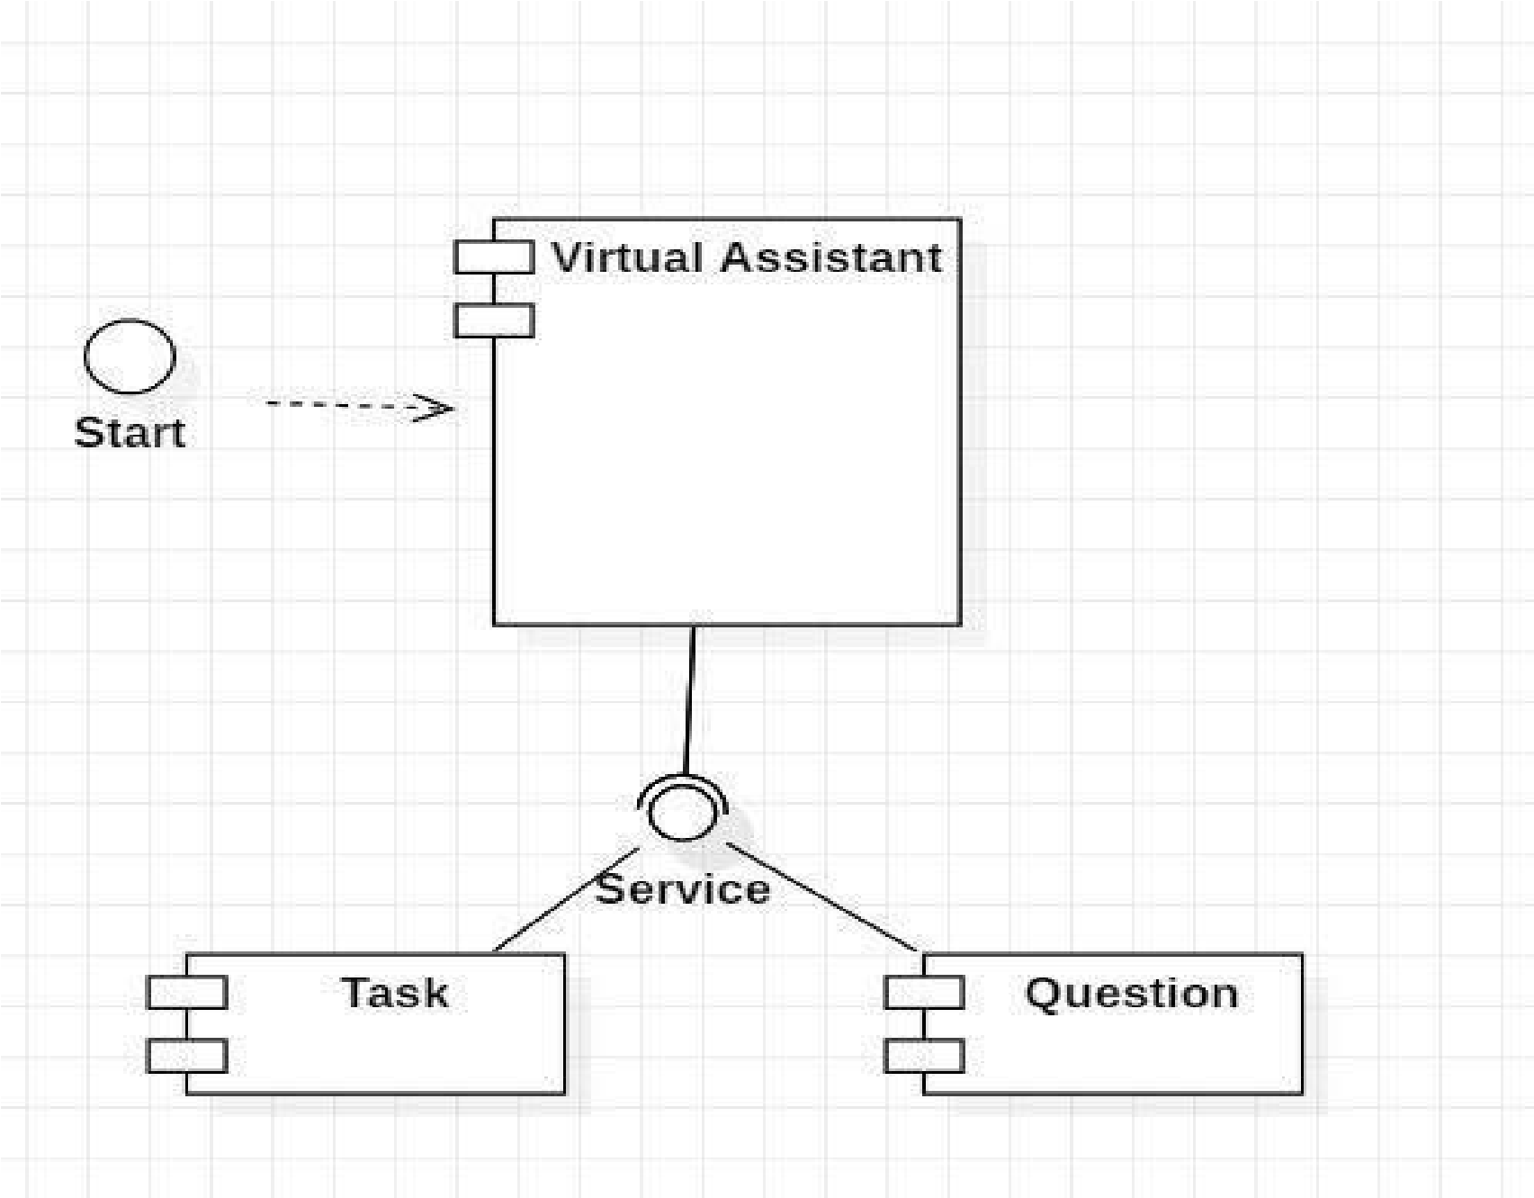

## 5. Testing

5.1 Importance of testing –

### • Test Case 1

**Test Title:** Response Time

**Test ID:** T1

**Test Priority:** Medium

**Test Objective:** To make sure that the system respond back time is efficient.

**Description:**

Time is very critical in a voice based system. As we are not typing inputs, we are speaking them. The system must also reply in a moment. User must get instant response of the query made.

### • Test Case 2

**Test Title:** Accuracy

**Test ID:** T2

**Test Priority:** High

**Test Objective:** To assure that answers retrieved by system are accurate as per gathered data.

**Description:**

A virtual assistant system is mainly used to get precise answers to any question asked. Getting answer in a moment is of no use if the answer is not correct. Accuracy is of utmost importance in a virtual assistant system.

**Note**: There might include a few more test cases and these test cases are also subject to change with the final software development

## 5. Report

In this project we have discussed a Voice Activated Personal Assistant developed using python. This assistant currently works online and performs basic tasks like weather updates, stream music, search Wikipedia, open desktop applications, etc. The functionality of the current system is limited to working online only.

Through this voice assistant, we have automated various services using a single line command. It eases most of the tasks of the user like searching the web, retrieving weather forecast details, vocabulary help and medical related queries. We aim to make this project a complete server assistant and make it smart enough to act as a replacement for a general server administration. The future plans include integrating JARVIS with mobile using React Native to provide a synchronised experience between the two connected devices. Further, in the long run, JARVIS is planned to feature auto deployment supporting elastic beanstalk, backup files, and all operations which a general Server Administrator does. The upcoming updates of this assistant will have machine learning incorporated in the system which will result in better suggestions with IoT to control the nearby devices similar to what Amazon’s Alexa does.

### 6. Drawbacks and limitations

* It will take some time to respond.

* Offline task response isn’t provided.

### 7. Future enhancement and conclusion

Voice assistants will continue to offer more *individualized* experiences as they get better at differentiating between voices. However, it’s not just developers that need to address the complexity of developing for voice as brands also need to understand the capabilities of each device and integration and if it makes sense for their specific brand. They will also need to focus on maintaining a user experience that is consistent within the coming years as complexity becomes more of a concern. This is because the visual interface with voice assistants is missing. Users simply cannot see or touch a voice interface.

The mass adoption of artificial intelligence in users’ everyday lives is also fueling the shift towards voice. The number of IoT devices such as smart thermostats and speakers are giving voice assistants more utility in a connected user’s life. Smart speakers are the number one way we are seeing voice being used. Many industry experts even predict that nearly every application will integrate voice technology in some way in the next 5 years.

The use of virtual assistants can also enhance the system of IoT (Internet of Things). Twenty years from now, Microsoft and its competitors will be offering personal digital assistants that will offer the services of a full-time employee usually reserved for the rich and famous.

### 8. Bibliography

1. For understanding of Python – GeeksforGeeks

(https://www.geeksforgeeks.org/) [www.pythonprogramming.net](http://www.pythonprogramming.net/) www.codeacademy.com

1. Document referred: Python code for Artificial Intelligence: Foundations of Computational Agents - David L. Poole and Alan K. Mackworth
2. Youtube channels referred:
   * CS Dojo
   * edureka